MANCOVA

**Description:**

MANCOVA is a type of analysis of variance that allows you to first control for variable(s) that change the relationship of the independent variable with the dependent variable, using a lot of dependent variables.

**Definitions/Abbreviations:**

CV – covariate. This variable changes with the dependent variables and is used to adjust the dependent variable to create equal groups or eliminate nuisance information. CVs can be either a continuous variable (such as age) or a dichotomous variable (such as gender). CVs are used to adjust the values of the dependent variables, usually to create larger group differences on your independent variables.

IV – independent variable. This variable *has* to be a dichotomous variable. You can put people into groups based on any category (gender, handedness) or your experimental manipulation (instructions versus no instructions).

DV – dependent variable. The dependent variable *needs* to be a continuous variable or another type of analysis might work better (see log regression). Your dependent variable should be the measurement you took in your study or what information you are expecting to see changed over groups.

DV combinations – Wilk’s Lambda, Roy’s Largest Root, Hotellings Trace, Pillia’s – these are all listed in the multivariate test. They are different ways to combine the DVs in such a way that creates large group differences on your IVs. Think of these as “giant means” for your DV, if you could create one mean of all the DVs such that your groups were maximally different. The most commonly used is Wilk’s Lamba.

**The process:**

**Power:**

You want to check how many people you need to run (or alternatively, how many more people you need in a study). Since you want to find the ANCOVAs are significant in the post hoc test, you can run this power analysis in the same way as ANCOVA. Alternatively, you can run a power analysis as if you are testing MANOVA, since generally controlling for a variable will give you more power.

**ANCOVA version:**

Set up options:

* Test family: F-tests
* Statistical Test: ANCOVA: Fixed effects, main effects, and interactions.
* Type of power analysis: A priori (most common)
* Effect size f: either guess at an effect size based on research, use a small effect size for good measure, or after a couple subjects run a prelim ANCOVA and use the current effect size. (You can click determine to convert eta squared to f).
* Alpha = .05
* Power = .80
* Numerator df = Levels – 1 or (levels-1)*(levels-1)
* Number of groups = number of conditions
* Number of covariates = number of CVs.

Hit calculate for the number of participants needed.

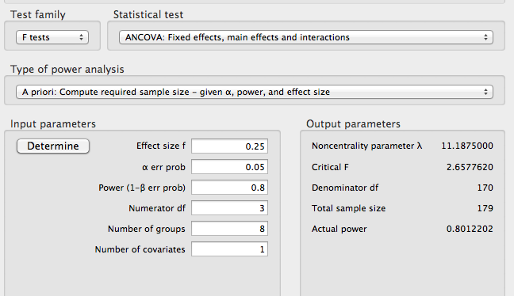

**MANOVA version:**

Set up options:

* Test family: F-tests
* Statistical Test: MANOVA: Special Effects and Interaction (for all between subjects).
* Type of power analysis: A priori (most common)
* Effect size f: either guess at an effect size based on research, use a small effect size for good measure, or after a couple subjects run a prelim MANOVA and use the current effect size. (You can click determine to convert eta squared to f).
* Alpha = .05
* Power = .80
* Number of groups = Number of conditions
* Number of predictors = number of IVs
* Number of response variables = number of DVs

Hit calculate for the number of participants needed.

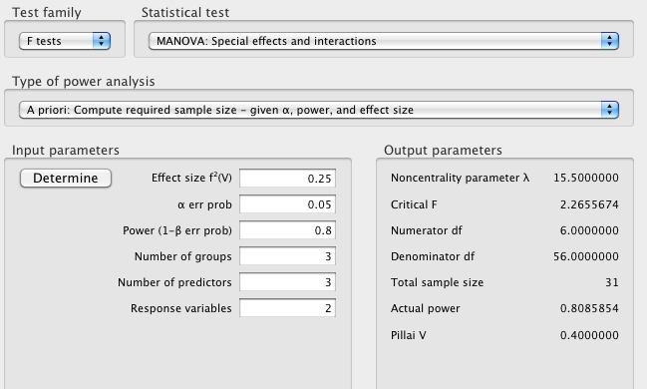

**Assumptions:**

Outliers:

* Univariate – outliers only on the CV or the DV. You want to check z-scores for people who are more than 3 (3 or -3) away from the mean.
* Multivariate – outliers on the CV and DV combination. This procedure uses Mahalanobis distance to make sure that people do not have a strange combination of answers on the CV and DV.
  + You can do both of these or just Mahalanobis. You may not want to eliminate people who are a univariate outlier on one variable, but you really should eliminate people who are multivariate outlier.

Multicollinearity:

* You want to check your CVs (if more than one) by using a correlation to make sure they do not overlap too much. If they overlap a great deal, then you want to use only one of them or combine them. Look for variables with r>.7.
* For the DVs, you want to make sure they are not too correlated r > .9 or you will need to combine them (or eliminate one) so you don’t lose power. Alternatively, you can check if the correlation is too low r < .10, which would indicate you should perform regular ANOVAs (since the DV combination process will lower your power).

Linearity: Linearity between the CV and DV (and DV/DV) is a very important issue. If you are using a regression to adjust the values of the DV with the CV, then there needs to be a linear relationship. You can check for this value using a fake regression or bivariate scatterplot.

Normality:

* Univariate – you want the CV and the DV to be normally distributed by themselves. You can check this information through frequencies and asking for a histogram. Non-normal distributions also have skew and kurtosis values over 3/-3.
* Multivariate – you also want the CV and DV combination to be normally distributed. You can check for multivariate normality by running a fake regression and asking for a histogram of the residuals.

Homogeneity: the variance of the groups from your IV need to be equal across both the DV and CV. You can check this information with a residual plot from your fake regression (you do not want raining or an unequal spread of the dots around 0). You can also use Levene’s test of homogeneity – you *do not* want p<.001.

Homoscedasticity: the spread of the scores on the CV need to be equal around all the values of the DV. You have to check this assumption by looking at a residual plot from a fake regression. You do not want a megaphone shape.

# Complete Example

Researchers have measured participants on their femininity and masculinity and want to know how those two variables affect a range of dependent measures. They measured self-esteem, and attitude about women’s roles to see if there were differences across femininity and masculinity scores. First, however, they want to control for neuroticism because it might be influencing our variables.

**IVS:**

Femininity scale (low versus high)

Masculinity scale (low versus high)

**DVS:**

Self esteem

Attitude toward the role of women

**CV:**

Neuroticism

**Assumptions Checks:**

Univariate outliers:

1. Analyze > Descriptive Statistics > Descriptives

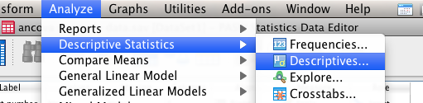

1. Move over the CV and DV into the descriptives box.
2. Hit save standardized values as variables.

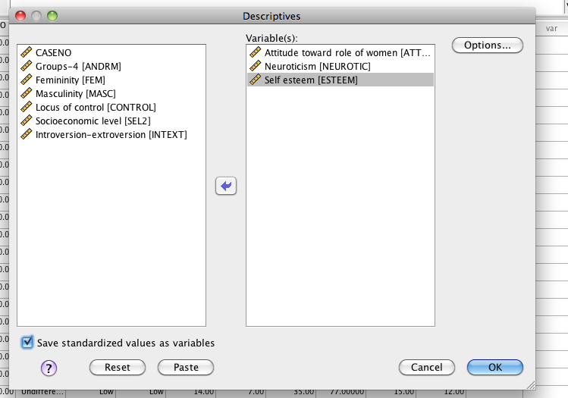

1. Hit options > skew and kurtosis.

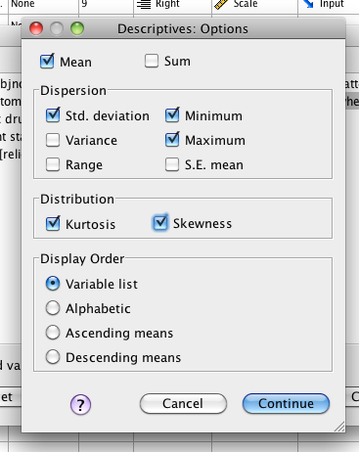

1. Look for univariate outliers.
2. Go back to the data set. You should see two new variables for z-scores of the CV and DV.
3. Sort those variables one at a time – look for values over 3 and -3 (right click sort).
4. There appear to be several outliers, but I’m going to check for multivariate outliers first.

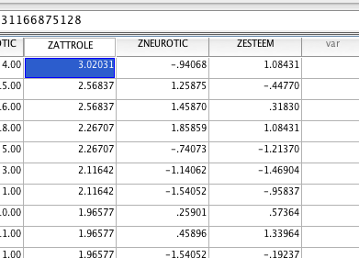

Multivariate outliers:

1. Create a fake variable to use for your fake regression.
2. Transform > compute variable.

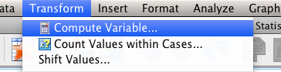

1. Call the target variable “random”. Use one of the random functions to create your random variable (I’ve used ChiSquare). The functions often have a ? for you to fill in a number for.

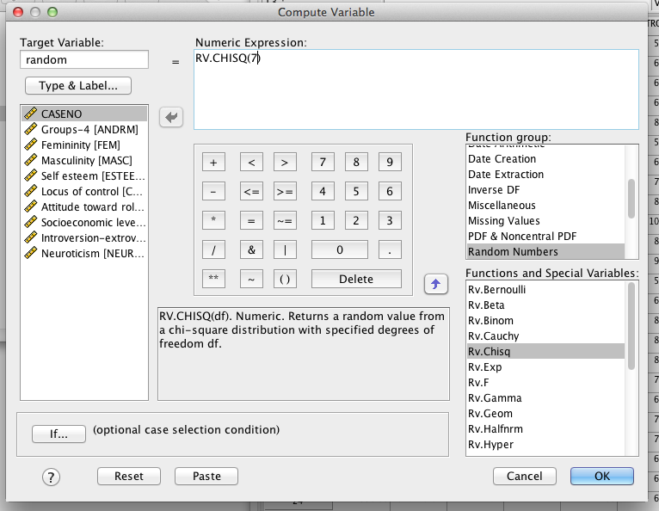

1. Hit “ok” and it will create a new random variable for you.
2. Run a fake regression. Analyze > Regression > Linear.

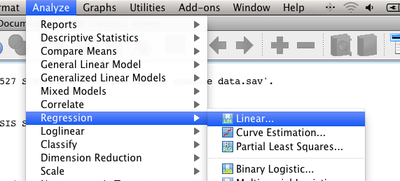

1. Move your random variable into the DV box. Put your CV and DVs into the independent(s) box. Do not use the IV!

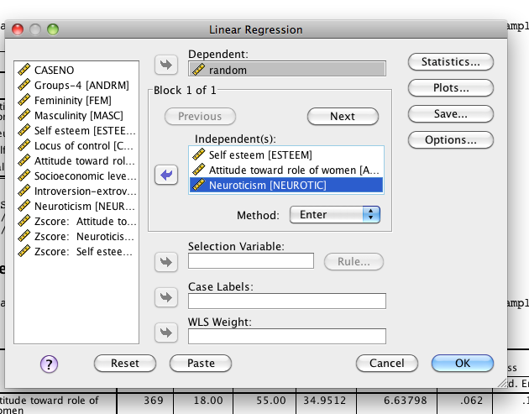

1. Hit Plots.

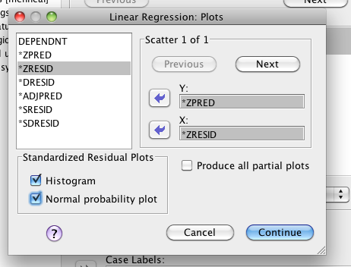

1. Put zpred in Y and zresid in X. This section will create the residual plots for other assumptions checks. Check histogram and normal probability plot.
2. Hit Save.

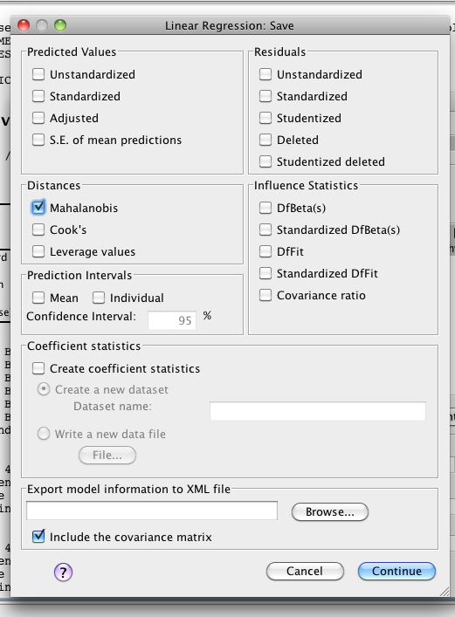

1. Check Mahalanobis – it will create another new variable for you to check.
2. Go back to the data set, and sort cases descending for Mahalanobis.
   1. You will need a cut off value to understand these scores.
   2. The cut off value is chi-square with degrees of freedom = number of variables, p<.001.
   3. Here we have three variables (CV and DV), p<.001, chi square = 16.27 cut off score.
   4. You will look for people who have a Mahalanobis score greater than > 16.27.

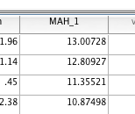

1. We do not have multivariate outliers. I am not going to exclude the univariate outlier because they were not a multivariate outlier.

Multicollinearity – you want to make sure the CVs and DVs are not *too* correlated (remember that the CV and DV should be correlated, so ignore that one):

1. Analyze > correlate > bivariate.

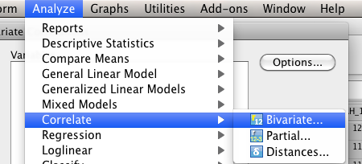

1. Move all your CV/DVs to the right hand side and hit ok.

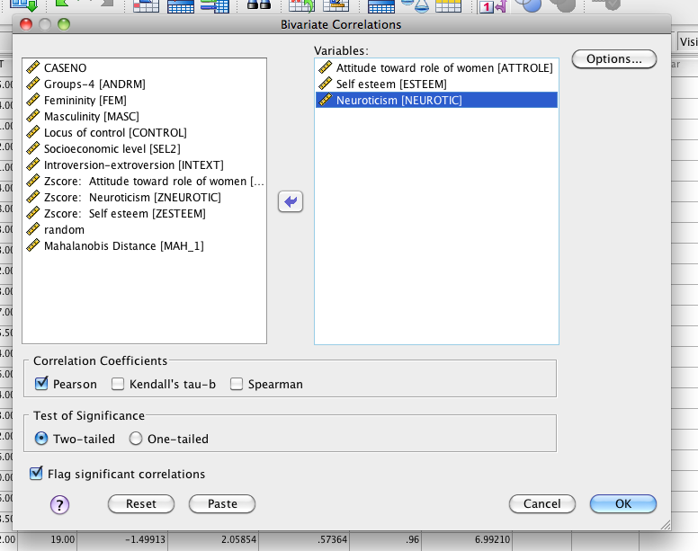

1. You want to make sure no correlations are over .7 for CVs (doesn't apply here because we only have one) and DVs over .9 or too low.

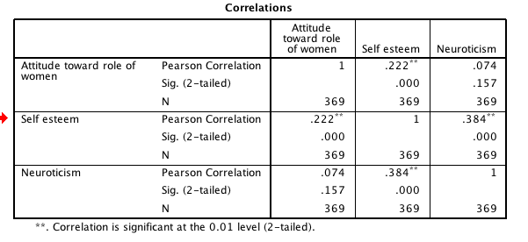

1. None of these are greater than .9, so we would be ok.

Linearity:

1. You can check linearity with the fake regression you’ve already run.
   1. IF YOU DELETED OUTLIERS: run the regression again, just as it describes above.
   2. IF YOU DID NOT DELETE OUTLIERS: you can use the output you already have.
2. Scroll down to the Normality Probability Plot.

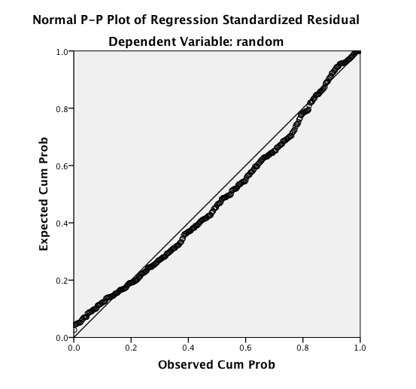

1. You want the dots to follow along the line moderately closely. This picture is starting to not be normal, but is ok.

Normality:

1. Univariate normality:
   1. You will need to get individual histograms of your CV and DV.
   2. Analyze > Descriptive Statistics > Frequencies.

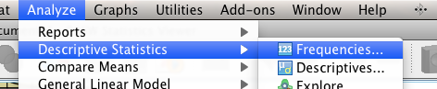

* 1. Move over the CV and DV into the right hand box. I turned off frequency tables because I didn’t want them.

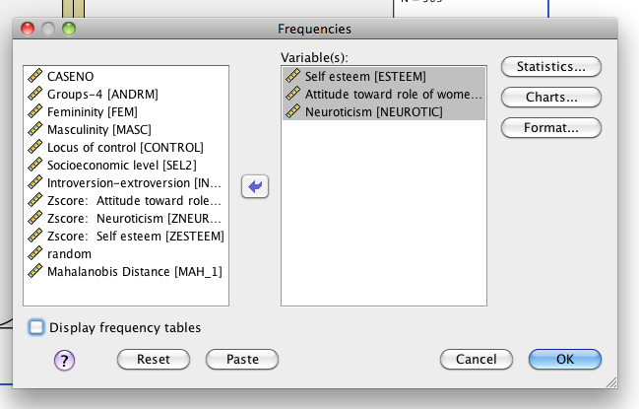

* 1. Hit charts. Pick Histogram and Normal Curve.

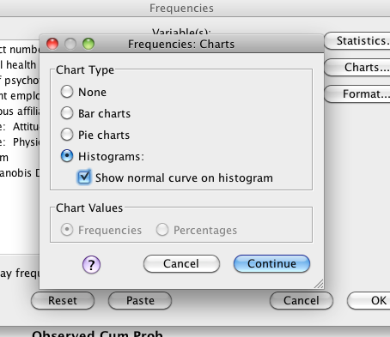

* 1. Hit continue and Ok.
  2. Now you’ll want to check the charts to make sure they look ok.

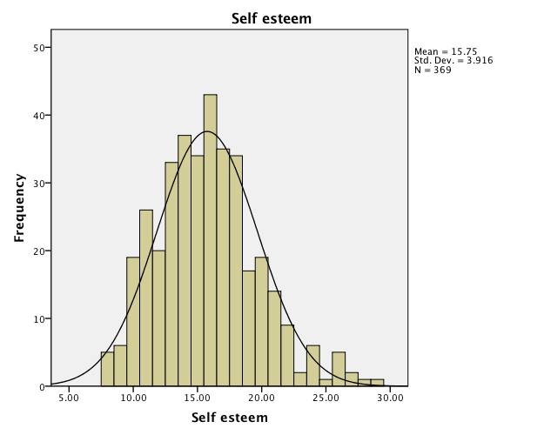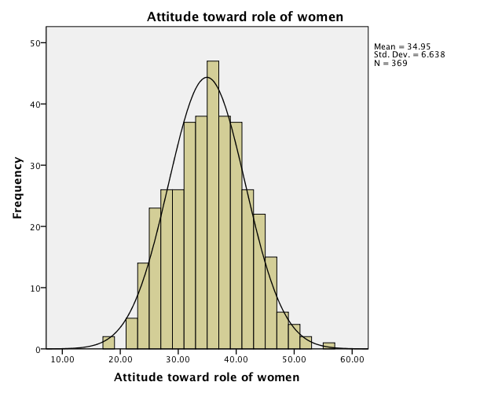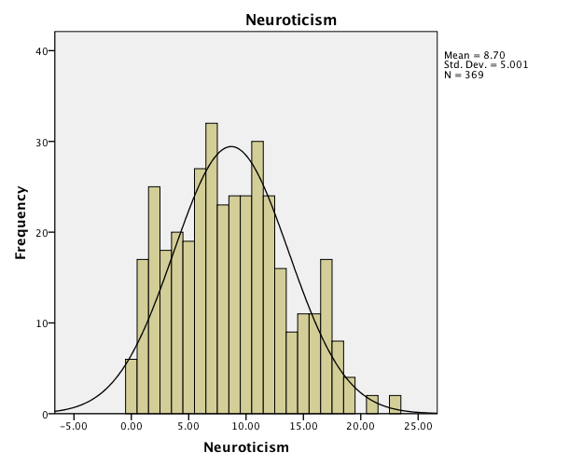

* 1. Both of these look ok, but maybe Physical Health is a little not-normal. I can go back and check skew and kurtosis if I’m not sure. (See the top when you ran descriptives).

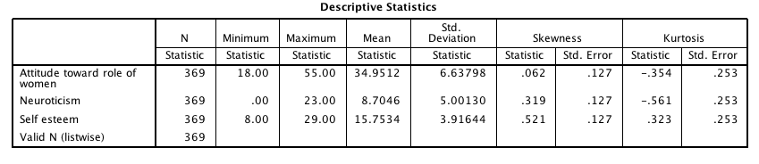

* 1. Both of these are under 3, or -3, so I’m good.

1. Multivariate Normality: use the histogram created from your fake regression to check the CV and DV combination.

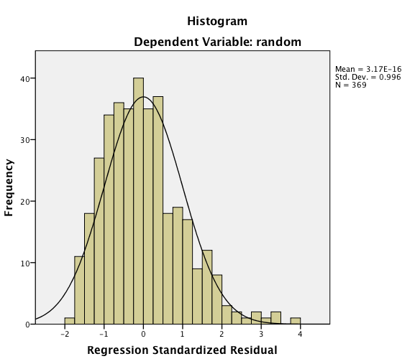

* 1. This histogram looks fairly normal between 2 and -2.

Homogeneity and Homoscedasticity: you can check these assumptions using the residual plot from the fake regression you ran earlier.

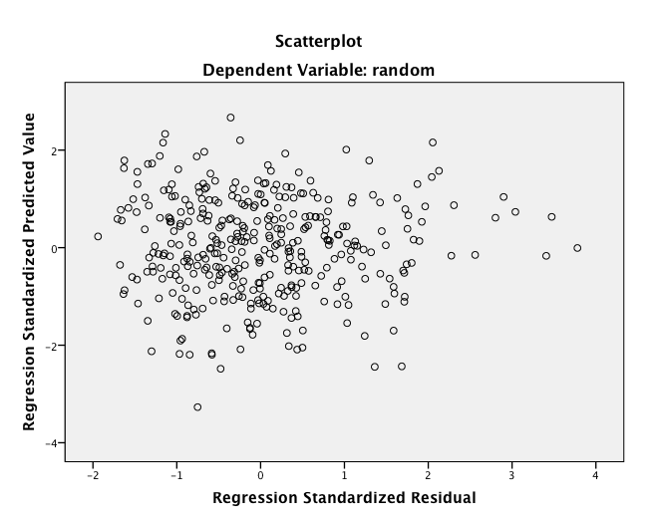

1. What to look for:
   1. Draw a line at 0.
   2. Homogeneity – is the spread above that line the same as below that line?
      1. These lines are complete lines.
      2. So it goes from 0 to 3 above and 0 to -3 below.
      3. You *do not* want a very large spread on one side and a small spread on the other side.
      4. If you encounter this problem – check Levene’s/Box’s when you run the data.
   3. Homoscedasticity – is the spread equal all the way across the zero line?
      1. These lines are the dashed lines.
      2. Do the dashed lines create a megaphone shape? No – you are good then.
2. Here we would have some problems with both … couple people out in the ¾ area that gives us heterogeneity and some heteroscedasticity.

**Running the MANCOVA:**

1. Analyze > General Linear Model > Multivariate

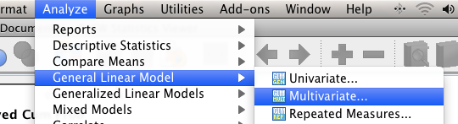

1. Dependent variable goes into the dependents box, IVs go in the fixed factor box, CVs go in the covariate box.
   1. Aren’t sure? Go back and figure out what type of variables they are (dichotomous, continuous) and see what type that makes them.

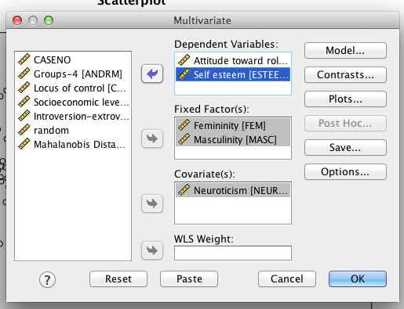

1. You cannot use post hoc because it’s got covariates ☹
2. Hit options. Move over your IVs to the right hand side. Ask for effect size, descriptive statistics and homogeneity (Box’s M).
3. Don’t forget the compare main effects box will give you Bonferroni for the *main effects only*. If you have an interaction, you will still have to do them by hand.

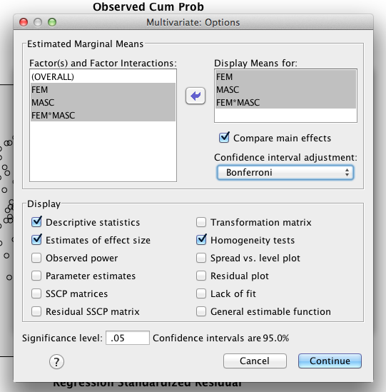

**Going from Output to Results Section:**

1. Homogeneity in Box’s M:
   1. If you were not sure about your homogeneity test with the residual plot, then you can check Box’s M for multivariate homogeneity. You *do not* want p<.001. Here we are ok because Box’s M p=.55.

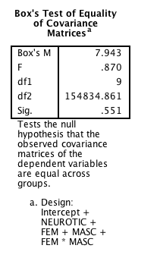

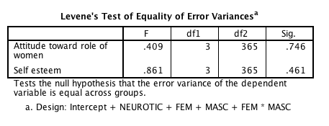

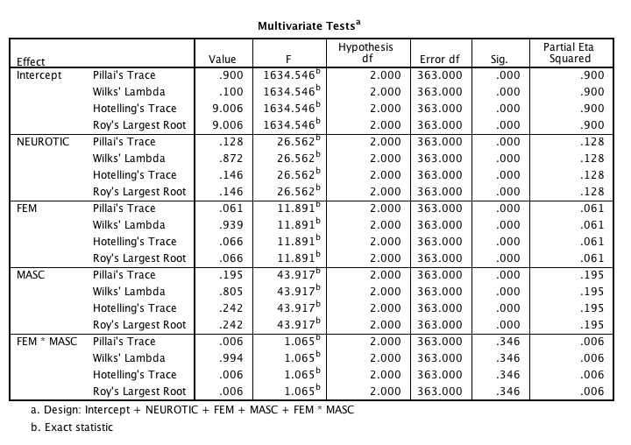

1. Multivariate test box – this box will give you the information for the MANCOVA for each main effect (fem, masc), interaction (fem*masc), and the covariate (neutroticism).
   1. Main effects: Femininity does show a significant effect on the combined dependent variables, *F*(2, 363) = 11.89, *p*<.001, *np*2 = .07, using Wilk’s lambda as a criterion.
   2. Main effects: Masculinity does show a significant effect on the combined dependent variables, *F*(2, 363) = 43.92, *p*<.001, *np*2 = .20, using Wilk’s lambda as a criterion.
   3. Interaction: The interaction was not significant on the combined dependent variables, *F*(2, 363) = 1.07, *p* = .35, *np*2 = .01, using Wilk’s lambda as a criterion.
   4. Covariate Significance: Neuroticism was a significant adjustor of the combined dependent variables, *F*(2, 363) =26.56, *p*<.001, *np*2 = .13.

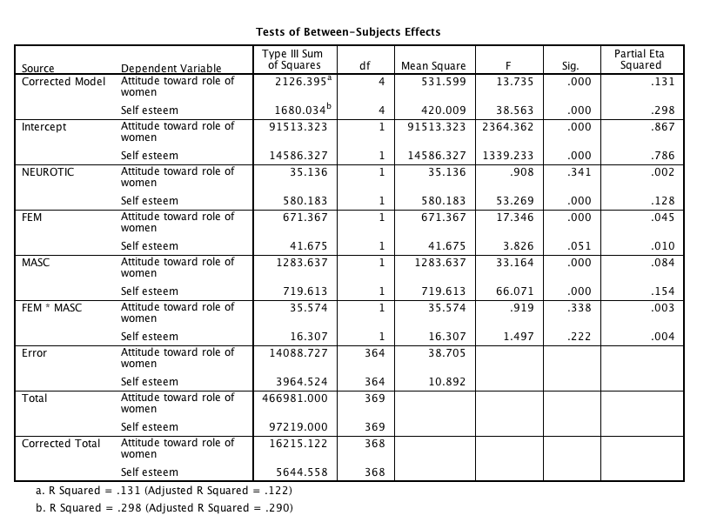

1. With only the significant effects, we use the ANCOVA boxes to determine which DV they impact.
   1. Main effects FEM:
      1. Femininity showed significant effects for attitudes toward the role of women, *F*(1, 364) = 17.35, *p*<.001, *np*2 = .05, and a marginal effect of self esteem, *F*(1, 364) = 3.83, *p*=.051, *np*2 = .01, after controlling for neuroticism.
      2. You’ll want to look at the estimated marginal means to explain that relationship.
      3. Low femininity groups (*M* = 32.06, *SE* = .64) had lower attitudes toward the role of women than high femininity groups (*M* = 35.21, *SE* = .41)
      4. However, low femininity groups (*M* = 15.81, *SE* = .34) reported higher self esteem than the high femininity groups (*M* = 15.03, *SE* = .22).

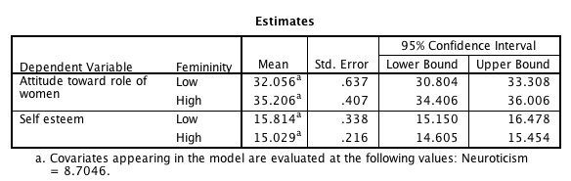

* 1. Main effects MASC:
     1. Masculinity showed significant effects for attitudes toward the role of women, *F*(1, 364) = 33.16, *p* < .001, *np*2 = .09, and a significant effect on self esteem, *F*(1, 364) = 66.07, *p* < .001, *np*2 = .15, after controlling for neuroticism.
     2. You’ll want to look at the estimated marginal means to explain that relationship.
     3. Low masculinity groups (*M* = 35.82, *SE* = .44) had higher attitudes toward the role of women than high masculinity groups (*M* = 31.44, *SE* = .62)
     4. However, low masculinity groups (*M* = 17.06, *SE* = .23) reported higher self esteem than the high masculinity groups (*M* = 13.78, *SE* = .33).

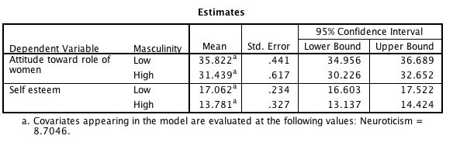

* 1. Covariate:
     1. Neuroticism was a significant adjustor of self-esteem, *F*(1, 364) = 53.27, *p*<.001, *np*2 = .13, but was not related to attitude towards the role of women, *F*(1, 364) = .91, *p* = .34, *np*2 < .01.
  2. What it means if your covariate is significant?
     1. It means that your CV is a significant adjustor of the DV.
     2. I would run a correlation to figure out how it’s adjusting.
     3. See above (multicollinearity) on how to run a bivariate correlation.
     4. Neuroticism is positively correlated with self-esteem, *r* = .384, *p*<.001, indicating that high neurotics also have high self-esteem.

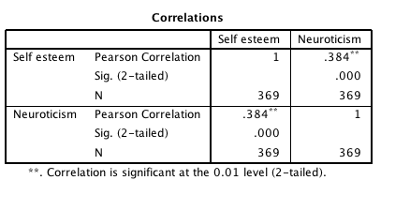

1. Post Hocs for interaction are explained in detail in the ANCOVA section – please go there for post hoc analyses.
   1. Remember you have to use the marginal means box with the adjusted means.
      1. But you’ll get the N values from the first descriptives box.
   2. You need to do those analyses by hand: <http://www.graphpad.com/quickcalcs/ttest1.cfm>

Be sure to use this box for graphs and post hocs for interactions (if necessary):

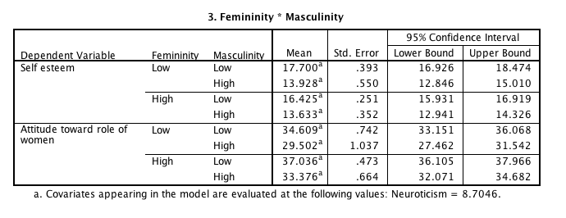

**Effect size:**

The adjusted marginal means are also the numbers you would enter into MOTE to get the effect size (independent t for between subjects).

**Charts:**

Chart builder will not do ANCOVA graphs easily. Boo ☹.

Chart primer in excel: http://office.microsoft.com/en-us/excel-help/create-a-chart-from-start-to-finish-HP010342356.aspx

Error bars in excel: http://office.microsoft.com/en-us/excel-help/add-change-or-remove-error-bars-in-a-chart-HP010342159.aspx

**Reminder**: you’ll need one for each DV, but generally people graph the interaction.

Example write up:

**Results**

Participants were measured on their attitude toward the roles of women, self-esteem, neuroticism, and femininity to examine the relationship between femininity and attitudes/self-esteem, while controlling for neuroticism. The data were screened for multivariate assumptions, and while there were several univariate outliers, no multivariate outliers were present (using Mahalanobis distance). Therefore, all participants were used for this analysis.

A 2 X 2 between subjects MANCOVA was used to analyze the role of femininity and masculinity on attitudes of women’s roles and self esteem after controlling for neuroticism. Using, Wilk’s lambda as a criterion, neuroticism was a significant adjustor of the combined dependent variables, *F*(2, 363) =26.56, *p*<.001, *np*2 = .13. Femininity showed a significant effect on the combined dependent variables, *F*(2, 363) = 11.89, *p*<.001, *np*2 = .07, after estimating out neuroticism, and masculinity also showed a significant effect on the combined dependent variables, *F*(2, 363) = 43.92, *p*<.001, *np*2 = .20. However, the interaction was not significant on the combined dependent variables, *F*(2, 363) = 1.07, *p* = .35, *np*2 = .01.

Individual between subjects ANCOVAs indicated that neuroticism was a significant adjustor of self-esteem, *F*(1, 364) = 53.27, *p*<.001, *np*2 = .13, but was not related to attitude towards the role of women, *F*(1, 364) = .91, *p* = .34, *np*2 < .01. Neuroticism is positively correlated with self-esteem, *r* = .384, *p*<.001, indicating that high neurotics also have high self-esteem. Femininity showed significant effects for attitudes toward the role of women, *F*(1, 364) = 17.35, *p*<.001, *np*2 = .05, and a marginal effect of self esteem, *F*(1, 364) = 3.83, *p*=.051, *np*2 = .01, after controlling for neuroticism. Low femininity groups (*M* = 32.06, *SE* = .64) had lower attitudes toward the role of women than high femininity groups (*M* = 35.21, *SE* = .41). However, low femininity groups (*M* = 15.81, *SE* = .34) reported higher self esteem than the high femininity groups (*M* = 15.03, *SE* = .22).

Masculinity showed significant effects for attitudes toward the role of women, *F*(1, 364) = 33.16, *p* < .001, *np*2 = .09, and a significant effect on self esteem, *F*(1, 364) = 66.07, *p* < .001, *np*2 = .15, after controlling for neuroticism. Low masculinity groups (*M* = 35.82, *SE* = .44) had higher attitudes toward the role of women than high masculinity groups (*M* = 31.44, *SE* = .62). However, low masculinity groups (*M* = 17.06, *SE* = .23) reported higher self esteem than the high masculinity groups (*M* = 13.78, *SE* = .33). Figures 1 and 2 demonstrate the adjusted condition means for both dependent variables.

*Figure 1.*

*Figure 2.*